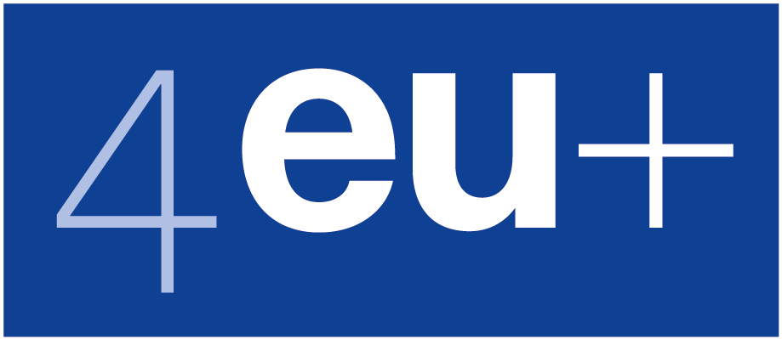 | 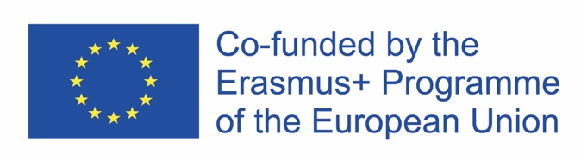

The Making of EU Environmental Regulation: Processes, Actors, and Tools of Implementing the Climate Action Strategy of the European Green Deal

A 4EU+ Spring School (online)

The consortium of European universities 4EU+ organises a Spring School devoted to EU policy making (its syllabus is attached to this note – see below). The University of Warsaw is supposed to recruit 6 participants with some background of economics, environmental and political science to take advantage of the course. By March 20, 2021, students and PhD candidates should electronically submit indication of their interest in the School (brief "motivation letters") accompanied by their average scores and any records of contribution to the School topic. The submissions addressed at springschool@wne.uw.edu.pl will be assessed by a Recruitment Committee nominated by the Dean of the Warsaw University Faculty of Economic Sciences (Dr. Olimpia Markiewicz, Prof. Karolina Safarzyńska, and Prof. Tomasz Żylicz). The list of participants selected by the Recruitment Committee will be electronically sent back to the applicants' electronic addresses by March 29, 2021. Any questions regarding the School and the recruitment procedure can be addressed to Professor Tomasz Żylicz tzylicz@wne.uw.edu.pl, the Warsaw University manager of the project.

The Making of EU Environmental Regulation Processes, Actors, and Tools of Implementing the Climate Action strategy of the European Green Deal
A 4EU+ Spring School (online)

Syllabus

Timing: Block A: April 21- 23
Block B: April 26 – 30
Block C: May 3 - 7 and May 14
Target Audience: Graduate students in Economics, Political Sciences, Public Policy, and Environmental Studies
Course level: M.Sc.
Course type: Online spring school (online lectures, online group work, online simulations)
ECTS: 6 credit points
Organizing department: Alfred-Weber-Institute of Economics, Heidelberg University
Course representatives: University of Copenhagen: Søren Bøye Olsen; University of Heidelberg: Timo Goeschl; Charles University, Prague: Vilém Novotný; University of Milan: Marzio Galeotti; University of Warsaw: Tomasz Zylicz
Instructors: Carsten Daugbjerg, Marzio Galeotti, Timo Goeschl (convener), Jan Karlas, Paola Mattei, Vilém Novotný, Søren Bøye Olsen, Karolina Safarzynska, Jale Tosun, Tomasz Zylicz

Climate change and environmental degradation are urgent problems requiring a coordinated effort, beyond a country-level. The Spring School aims at making students familiar with the context and conditions of EU environmental and climate policy. We will discuss EU’s strategy to make the European Economy sustainable, namely to implement the European Green Deal. Basic knowledge of key methods, theories, approaches in the fields of political science and economics will be provided in a comprehensive manner. They will be later put in use by students to work (in groups) on applied environmental and climate policy at the EU level.

Learning objectives
After the School, students will have become competent
- about the process through which EU environmental policies emerge, take shape, and become implemented,
- the institutions involved in initiating, shaping, defining, and implementing EU environmental policies;
- the tools and methods used to determine costs and benefits of alternative policy designs;
- the different ways in which different actors use these tools and methods to further their interest at the design and implementation stage.

Prerequisites
This is a graduate level course for students enrolled in economics, political sciences, public policy, or environmental studies.

Admission
Due to the nature of the learning objectives and teaching methods, this course has capacity limits. Students interested in participating should contact their local course representative.

Assessment
There are two assessment components
- Policy brief (weight: 50% of the grade): This is a 1,000 word document prepared during Block B that sets out the key aspects of a specific policy challenge within the Climate Action strategy of the European Green Deal. A particular emphasis is on preparing a concise, yet factually rich policy brief for policymakers.
- National position paper (50%): This is a 2,000 word document prepared during Block C that sets out the national position on a specific .
Students work together in working groups on the briefs and position papers, but each student submits their own version.

Structure
The Spring School consists of three blocks, A, B, and C. Each is preceded by some preparatory tasks.

Block A (April 21, 22, and 23): Whole-day attendance required for online lectures, peer-to-peer teaching, group work, quizzes and other online formats on April 21 and 22, and half-day attendance on April 23.

Block B (April 26-30): A total of 10-12 hours loosely structured interaction time in working groups of five students to develop a policy brief on a key aspect of the Climate Action strategy of the European Green Deal. Examples are: Extending the EU ETS; Carbon border adjustments; Innovation policy towards zero emissions.

Block C (May 3 - 7 and May 14): A total of 10-12 hours semi-structured interaction time in working groups of five to develop national position paper for European Green Deal (May 3 - 7) plus 3 hours fixed-schedule simulation on May 14 (afternoon).

